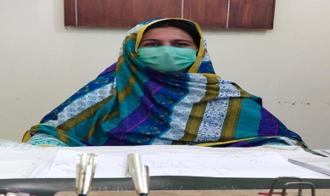
INFORMATION REQUIRED FOR UNIVERSITY WEBSITE
Name | Dr. Tabassum Yaseen (HEC Approved Supervisor)
Father’s Name | Yaseen Khan
Gender | Female
Nationality | Pakistani
Designation | Assistant Professor
Additional Charge | Head of Department Botany and Zoology BKUC
 | HEC Focal Person (PQR) BKUC
Highest Qualification | Ph.D.
Subject/Discipline | Botany
Thesis Title | Arbuscular mycorrhizal fungal association in Pulses
Date of completion | 23-Oct-2013
University | University of Peshawar KP Pakistan
Country | Pakistan
Area of Specialization | - Mycorrhizae Ecology,  - Mycology and Plant Pathology
Job Type | Teaching/ Research/Administration
BPS | 19
Date of Birth | 01-January-1981
Joining Date | 22-June-2014
Cell No | +923329948764
Email | tabassumyaseen@bkuc.edu.pk/zarko.khan@gmail.com
M. Phil Students Supervised | - Ten (10) Supervised  - Six (06) Under supervision
Ph.D Students Supervised | - Three (03) under supervision
Teaching and Research Experience | 07 Years
Area of Expertise | - Mycorrhizae Ecology  - /Mycology/  - Plant Pathology  - Molecular biology of Arbuscular Mycorrhizal fungi
Current Status | Assistant Professor (Regular)

