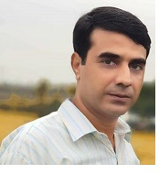
INFORMATION REQUIRED FOR UNIVERSITY WEBSITE
Name | Dr. Imtiaz Ahmad
Father’s Name | Fasih Ahmad
Gender | Male
Nationality | Pakistani
Designation | Assistant Professor
Additional Charge | Deputy Director ORIC
Highest Qualification | Ph.D
Subject/Discipline | Botany
Thesis Title | Pharmacognosy of Viola canescens
Date of completion | 18-March-2018
University | University of Peshawar
Country | Pakistan
Area of Specialization | Pharmacognosy/Phytochemistry/Nanotechnology
Job Type | Teaching/ Research
BPS | ……….
Date of Birth | 15-June-1981
Joining Date | 20-Feb-2013
Cell No | +923469429310
Email | drimtiazahmad@bkuc.edu.pk
M.Phil Students Supervised | 13
Ph.D Students Supervised | Nil
Teaching and Research Experience | 8 Years
Area of Expertise | Pharmacognosy/Phytochemistry/Nanotechnology/Stress physiology
Current Status | Assistant Professor (Contract)

