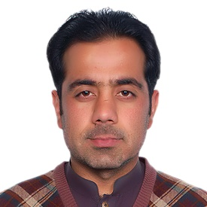INFORMATION REQUIRED FOR UNIVERSITY WEBSITE
Name | Dr. Javed Iqbal
Father Name | Abdul Janan
Gender | Male
Nationality | Pakistani
Designation | Assistant Professor
Additional Charge | N/A
Highest Qualification | PhD
Subject/Discipline | Botany
Thesis Title | Green Synthesis of Multifunctional Metal Oxide Nanoparticles from Medicinal Plants and their Biological Applications
Date of Completion | July, 27, 2020
University | Quaid-i-Azam University, Islamabad
Country | Pakistan
Area of Specialization | Green Synthesis of functional Nanomaterials and their Biological applications
Job type | Contract
BPS | N/A
Date of Birth | May, 09,1989
Joining Date | November, 11, 2020
Cell No | 03338886505, 03028886505
Email | Javed89qau@gmail.com, javed.iqbal@bkuc.edu.pk
MPhil Students Supervised | N/A
PhD Students Supervised | N/A
Teaching & Research Experience | ????????
Area of Expertise | Research interests include  - Green synthesis of nanoparticles (NPs) and their biological applications  - Functional Nanomaterials  - Surface Functionalization  - Bioassay screening  - Medicinal plants extract preparation  - Isolation of natural products of commercial values and their promising biological activities
Current Status | Fixed pay

